


News Release
For Immediate Release

Hitachi Energy and Rockwell Automation unite power and automation to help industries accelerate electrification
Grid-to-process approach integrates energy supply and production demand to improve efficiency, optimize resources, and simplify complex industrial projects.
⋅ Brings together deep expertise across domains spanning electrical infrastructure, grid and process automation, and digital technologies
⋅ Supports a unified approach to planning, delivering, and operating capital-intensive industrial facilities
⋅ Initially focused on mining and metals, with potential applications across other energy-intensive industries
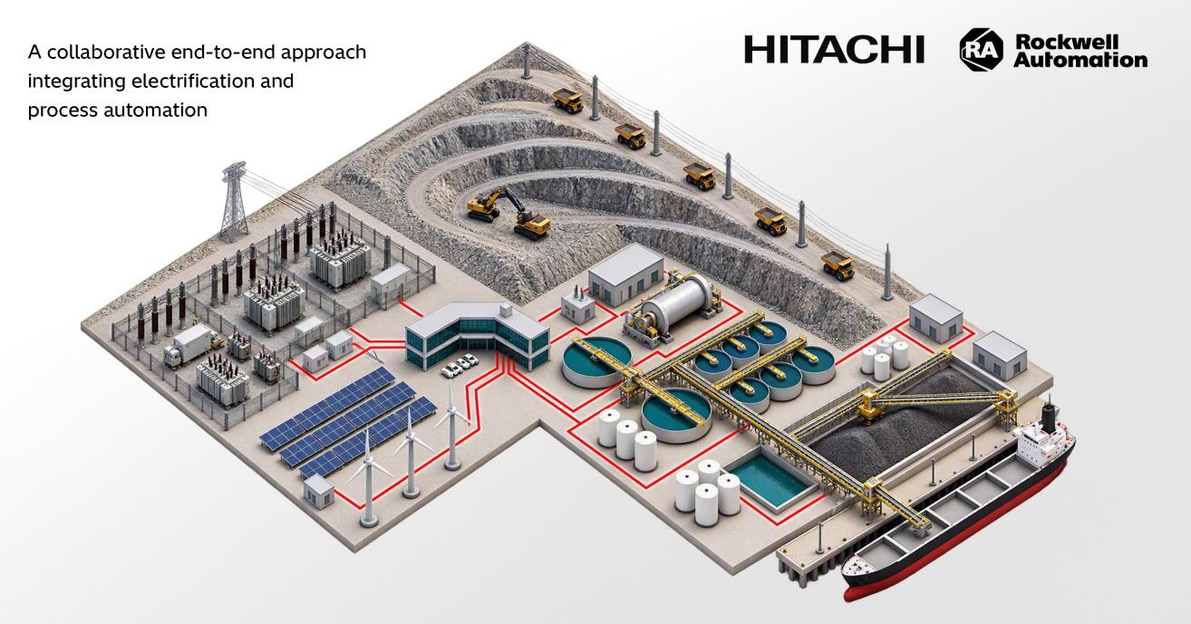

Johannesburg, South Africa, 03 November, 2026 - Hitachi Energy, a global leader in electrification, and Rockwell Automation, Inc. (NYSE: ROK), the world's largest company dedicated to industrial automation and
digital transformation, announced today a collaboration centered on an integrated grid-to-process architecture that combines the infrastructure powering industrial facilities with the systems that manage production.

As industrial companies face rising power demand, growing pressure to decarbonize, and increasing constraints on capital investment, electrical systems and production operations can no longer be planned in isolation. Decisions about power infrastructure increasingly influence operational performance, while production requirements play a larger role in planning, deploying, and operating electrical systems.

By bringing together expertise in grid connection, power quality, energy management, protection and control, process automation, and digital operations, Hitachi Energy and Rockwell Automation aim to help customers

achieve a more seamless integration of grid and process systems. Planning power and production systems together can streamline engineering, improve cross-functional coordination, and support digital mining operations, while exploring scalable and modular approaches that can support future expansion and evolving electrification
requirements.

Mining and metals will serve as the initial focus of the collaboration. As demand for critical minerals grow, mining companies must simultaneously expand production, modernize operations, and accelerate the electrification of their own facilities. Analysis estimates that growth capital expenditures for new capacity could require $1 trillion
USD over the next decade. Reliable, high-quality power is fundamental to these operations, particularly in energy-intensive processes such as crushing, grinding, conveying, and processing, where disruptions can affect equipment utilization, production continuity, and operating costs.

“Electrification is changing the economics of industrial operations. Decisions about energy infrastructure increasingly influence productivity, sustainability, and growth,” says Marco Berardi, Head of Grid & Power Quality Solutions and Service at Hitachi Energy. “As industries expand capacity and modernize their operations, they need greater coordination between the systems that power their facilities and the processes that drive production. By bringing together the strengths of Hitachi Energy and Rockwell Automation, we can help customers navigate this complexity, improve operational performance, and support more efficient, resilient, and sustainable industrial
operations.”

“The future of industry will be defined by how effectively companies integrate energy and production,” said Brian Holte, vice president, Global Industry Growth, Rockwell Automation. “By combining Hitachi Energy’s leadership in electrification with Rockwell Automation’s experience in automation and digital transformation, we help customers design, build, and operate more intelligent, resilient, and sustainable sites. Together, we are enabling a grid-to-
process approach that improves performance, accelerates growth, and helps customers bring new manufacturing capacity online faster, more predictably, and at greater scale.”

Once facilities are operational, the combination of electrification, automation, and digital technologies can provide greater visibility across energy consumption, production performance, and asset utilization. The approach also
provides a scalable foundation for future capacity expansion, increased electrification, and the integration of new energy resources.

The companies are exploring opportunities in solution development, customer engagement, and selected industrial applications. While initially focused on mining and metals, the companies see broader potential across other energy-intensive industries.

Reference:
McKinsey & Co. Report, “The capex crystal ball: Beating the odds in mining project delivery,” Predicting cost and schedule overruns in mining | McKinsey, November 2024.
About Hitachi Energy
Hitachi Energy is a global leader in electrification, powering the electricity era to meet the energy demands of today, and the next 25 years. As the energy arm of Hitachi Group, over three billion people depend on our pioneering, mission critical technologies to power their daily lives. With over a century of innovation, we are addressing the most urgent energy challenge of our time: driving the evolution of the world’s energy system to ensure abundant, secure, affordable, and sustainable power for today’s generation and the next. With an unparalleled installed base in over 140 countries, we are the grid ecosystem partner across the utility, industry, data center, and transportation sectors. Headquartered in Switzerland, we employ over 56,000 people in 60 countries and generate revenues of around $20 billion USD.
Https://www.hitachienergy.com
https://www.linkedin.com/company/hitachienergy https://x.com/HitachiEnergy
About Hitachi, Ltd.
Through its Social Innovation Business (SIB) that brings together IT, OT (Operational Technology) and products, Hitachi aims to be a global leader in continuously transforming social infrastructure through digital, contributing to a harmonized society where the environment, wellbeing, and economic growth are in balance. Hitachi operates

worldwide across four sectors – Digital Systems & Services, Energy, Mobility, and Connective Industries – as well as a Strategic SIB Business Unit focused on new growth areas. With Lumada at its core, Hitachi creates value by combining data, technology and domain knowledge to solve customer and social challenges. Revenues for FY2025 (ended March 31, 2026) totaled 10,586.7 billion yen, with 606 consolidated subsidiaries and approximately 290,000
employees worldwide. Visit us at www.hitachi.com.

Hitachi Energy media contact
media.relations@hitachienergy.com

About Rockwell Automation
Rockwell Automation, Inc. (NYSE: ROK), is a global leader in industrial automation and digital transformation. We connect the
imaginations of people with the potential of technology to expand what is humanly possible, making the world more productive and more sustainable. Headquartered in Milwaukee, Wisconsin, Rockwell Automation employs approximately 26,000 problem solvers dedicated to our customers in more than 100 countries as of fiscal year end 2025. To learn more about how we are bringing the Connected Enterprise to life across industrial enterprises, visit www.rockwellautomation.com.

Rockwell Automation media contact
Ed Moreland
Head of Government Affairs and Corporate Communications
+1 571-296-0391
Edward.Moreland@RockwellAutomation.com

Investor Relations contact for Rockwell Automation
Aijana Zellner
Head of Investor Relations and Market Strategy
+1 440-289-8439
azellner@rockwellautomation.com

