Hitachi Energy’s solutions electrify Geita Gold Mine and cut CO₂ emissions
- AngloGold Ashanti’s Geita Gold Mine to be connected to Tanzania’s national electricity grid, powered 45.5 percent by renewable energy
- The 80 percent reduction in diesel usage will help the mine save on the cost of fuel for power generation
- Ensuring grid stability, Hitachi Energy’s power quality STATCOM solution is the first of its kind in Africa

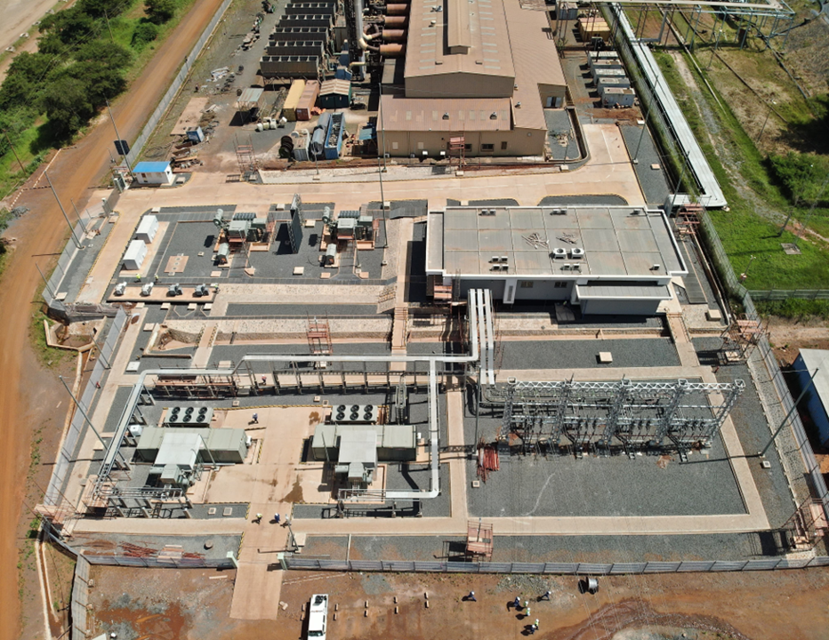
Anglo Gold Ashanti, Geita Mine, Tanzania - PCS 6000 STATCOM –

Tanzania, September 22, 2025 - Hitachi Energy announces the deployment of its power quality solution to securely connect Tanzania’s leading gold producer, Geita Gold Mine Limited (GGML), to the national grid, which comprises 45.5 percent renewable energy sources¹. The project replaced 80 percent of the fossil-fuel gensets used by GGML for power generation and is expected to reduce the site’s carbon emissions by at least 50 kilotons (Kt) CO² per annum.

AngloGold Ashanti plc, the owner of GGML, collaborated with the government of Tanzania, its power utility Tanzania Electric Supply Company (TANESCO), and Hitachi Energy to execute the project.

As part of the project, Hitachi Energy delivered a state-of-the-art power electronic converter that stabilizes the mine’s connection to the grid, featuring a PCS 6000 STATCOM system. The system’s performance is further optimized through MicroSCADA, which provides crucial real-time monitoring and control.

With extensive project execution capabilities, Hitachi Energy engaged with partners in Tanzania, providing supervision and training to contractors, fostering skills development, and contributing to community upliftment. The company strengthened local capacity through these efforts, ensuring long-term success and sustainability while delivering cutting-edge technology.

"We are proud to support Geita Gold Mine Limited in this landmark achievement. AngloGold Ashanti’s unwavering commitment to sustainability and climate resilience across their business, value chain, and communities sets a remarkable standard in the industry," said Mohamed Hosseiny, Managing Director at Hitachi Energy in Africa. "It is reassuring that our pioneering technologies and solutions are advancing a sustainable energy future for all."

The project is a testament to Hitachi Energy's expertise in providing solutions, executing projects, and developing pioneering technologies. The PCS 6000 STATCOM system was pre-assembled, tested to the highest standards, and shipped as a containerized package for fast installation on-site. Its compact design and adaptability to harsh mining environments make it a compelling solution for industrial and remote grid applications.

Electrification solutions, like the STATCOM system, are vital to accelerating the global energy transition. By delivering innovative technology to high-impact markets, Hitachi Energy empowers the world’s energy system to be more sustainable, secure, resilient, and affordable.

Footnote
¹ TANESCO, Electricity Sub-Sector Regulatory Performance Report For The Financial Year 2023/24
https://www.tanesco.co.tz/attachments/media/press_releases/Electricty_Sub_Sector_Peformance_Report_FY_2023_2024.pdf

About Hitachi Energy
Hitachi Energy is a global technology leader in electrification, powering a sustainable energy future with innovative power grid technologies with digital at the core. Over three billion people depend on our technologies to power their daily lives. With over a century in pioneering mission-critical technologies like high-voltage, transformers, automation, and power electronics, we are addressing the most urgent energy challenge of our time – balancing soaring electricity demand, while decarbonizing the power system. With an unparalleled installed base in over 140 countries, we co-create and build long-term partnerships across the utility, industry, transportation, data centers, and infrastructure sectors. Headquartered in Switzerland, we employ over 50,000 people in 60 countries and generate revenues of around $16 billion USD.
https://www.hitachienergy.com
https://www.linkedin.com/company/hitachienergy
https://x.com/HitachiEnergy

About Hitachi, Ltd.
Through its Social Innovation Business (SIB) that brings together IT, OT (Operational Technology) and products, Hitachi contributes to a harmonized society where the environment, wellbeing, and economic growth are in balance. Hitachi operates globally in four sectors – Digital Systems & Services, Energy, Mobility, and Connective Industries – and the Strategic SIB Business Unit for new growth businesses. With Lumada at its core, Hitachi generates value from integrating data, technology and domain knowledge to solve customer and social challenges. Revenues for FY2024 (ended March 31, 2025) totaled 9,783.3 billion yen, with 618 consolidated subsidiaries and approximately 280,000 employees worldwide. Visit us at https://www.hitachi.com.

