FOR IMMEDIATE RELEASE

Hitachi Energy and SP Energy Networks to boost renewable energy flow

- Innovative combination of two technologies strengthens grid stability and enhances the flow of renewable energy across the UK.
- Up to 280 MW of additional renewable energy to be added to the electricity grid, with the potential to power over 360 000 homes.

Hitachi Energy has won an order from SP Energy Networks to design and deliver a first-of-its-kind power quality solution to balance the grid and boost the flow of renewable energy across the UK. The solution will enable SP Energy Networks, the electricity network operator for Central & Southern Scotland and Merseyside, Cheshire, North & Mid-Wales and North Shropshire to add more renewables into the grid and facilitate the phase-out of fossil fuels.

The project, located at SP Energy Networks’ substation at Eccles, consists of two sets of an SVC Light® STATCOM¹ and a synchronous condenser controlled centrally by the MACH™ control system, connected at a common electrical node. This unique combination of technologies will maximise the future power system’s potential while also providing increased system resilience, thus supporting the increasing integration of renewables into the electricity grid.

Each STATCOM installation uses Hitachi Energy’s advanced power electronics and technology-leading MACH² control and protection solution to provide system strength, instantaneous voltage control and enable maximum power flow. This technology, which entrusts a STATCOM to control a local synchronous condenser, is market leading. It builds on an earlier collaboration between SP Energy Networks and Hitachi Energy on the network innovation competition project Phoenix supported by Ofgem, the energy regulator for the UK.

“The innovative power quality solution will increase the transfer capacity across the UK by up to 280 MW by improving the transmission network’s strength as more renewable generation is connected in Scotland,” said Billy Moore, Senior Project Manager at SP Energy Networks. “The criticality of technology such as this will become more important as we reduce the usage of fossil fuels.”

“We are delighted to have co-created this innovative solution with SP Energy Networks, which will maintain grid stability and enable more clean electricity to flow through the system in the UK,” said Marco Berardi, Head of Grid & Power Quality Solutions and Service business at Hitachi Energy. “This pioneering innovation is yet another addition to our ever-evolving portfolio of power quality solutions that help grid operators overcome the immediate and long-term challenges of the energy transition.”

With the integration of more renewable energy into the grid and the move away from conventional power plants, transmission system operators face a number of challenges. In this project, the SVC Light STATCOM and synchronous condenser with combined control generates or absorbs reactive power to adjust the grid voltage and maintain system resilience.

Notes to editors
1. Static synchronous compensator (STATCOM) continuously provides variable reactive power in response to voltage variations, supporting the stability of the grid.
2. The MACH Control System acts as the brain of SVC Light using state-of-the-art computers, microcontrollers and digital signal processors.

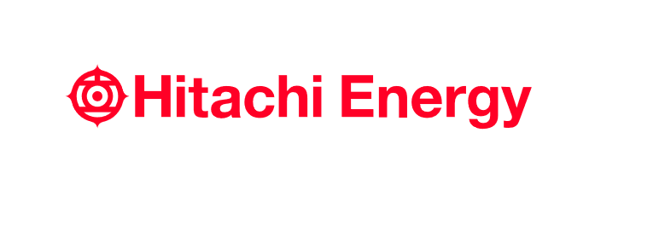
- End -

About Hitachi Energy Ltd.
Hitachi Energy is a global technology leader that is advancing a sustainable energy future for all. We serve customers in the utility, industry and infrastructure sectors with innovative solutions and services across the value chain. Together with customers and partners, we pioneer technologies and enable the digital transformation required to accelerate the energy transition towards a carbon-neutral future. We are advancing the world's energy system to become more sustainable, flexible and secure whilst balancing social, environmental and economic value. Hitachi Energy has a proven track record and unparalleled installed base in more than 140 countries. We integrate more than 150 GW of HVDC links into the power system, helping our customers enable more wind and solar. Headquartered in Switzerland, we employ more than 40,000 people in 90 countries and generate business volumes of over $10 billion USD.
https://www.hitachienergy.com
https://www.linkedin.com/company/hitachienergy
https://twitter.com/HitachiEnergy

About Hitachi, Ltd.
Hitachi drives Social Innovation Business, creating a sustainable society through the use of data and technology. We solve customers' and society's challenges with Lumada solutions leveraging IT, OT (Operational Technology) and products. Hitachi operates under the business structure of "Digital Systems & Services" - supporting our customers' digital transformation; "Green Energy & Mobility" - contributing to a decarbonized society through energy and railway systems, and "Connective Industries" - connecting products through digital technology to provide solutions in various industries. Driven by Digital, Green, and Innovation, we aim for growth through co-creation with our customers. The company's consolidated revenues for fiscal year 2022 (ended March 31, 2023) totaled 10,881.1 billion yen, with 696 consolidated subsidiaries and approximately 320,000 employees worldwide. For more information on Hitachi, please visit the company's website at https://www.hitachi.com.

Contacts:
Media Contact:
Lerato Nkosi
Country Communications Manager, South and Southern Africa
Hitachi Energy Ltd.
+27 73 644 5464
lerato.nkosi@hitachienergy.com
# # #

