FOR IMMEDIATE RELEASE

Hitachi Energy's PQactiF solution elevates power quality to new thresholds
Sophisticated algorithms analyze and eliminate electrical disturbances, leading to even greater accuracy and efficiency in power quality management.

While we expect uninterrupted and stable electricity access wherever we go, reality often falls short. The efficient distribution of electricity to consumers relies on the power quality of the network, a crucial factor in guaranteeing a reliable and seamless power supply.

Low-voltage harmonic filters address power quality issues by mitigating harmonic distortions, compensating for reactive power, and stabilizing voltage levels. They are key in improving reliability, efficiency, and productivity while reducing downtime and costs in industrial, commercial, or residential applications.

The economic effects of poor power quality

Power quality issues frequently arise due to compatibility problems between the electrical grid and the constantly changing array of electronic devices and equipment. The rising prevalence of electronic devices, from LED lamps and computers to sophisticated medical equipment and industrial machinery, has heightened susceptibility to power disruptions.

Poor power quality can have many consequences, impacting businesses and individuals. This includes damage to electrical installations, unexpected production downtimes, inefficient production processes, and high energy consumption due to system losses. Moreover, organizations may face penalties imposed by grid operators due to reactive power in their installations. The financial implications are significant, hindering peak performance and preventing assets from achieving their full potential.

Calculating the economic effects of poor power quality can be challenging, but the consequences are tangible. For instance, a power quality issue during production in the food and beverage industry could result in thousands of spoiled products. In healthcare settings, malfunctioning electrical or electronic equipment due to power quality problems can pose a significant risk to a patient’s health, potentially leading to misdiagnosis with consequences on people’s well-being. Recognizing these consequences is critical to understanding the need for specific action plans to improve power quality.

Introducing PQactiF: Hitachi Energy's innovative filtering solution

For decades, passive filter technology has been the solution of choice to address power quality issues. This technology employs capacitors and inductors to filter unwanted harmonics and electrical noise at a pre-defined frequency, providing effective and cost-efficient solutions. However, passive filtering has limitations in canceling varying harmonics over the load range and may be less suitable for changing operating conditions. In contrast, active filter technology, pioneered by Hitachi Energy1 in the 1990s, actively eliminates harmonics and electrical noise in real-time at nearly any frequency using electronic components, resulting in a cleaner, more stable, and safer power supply.

PQactiF is Hitachi Energy’s latest technological development — a low-voltage active harmonic filter solution that raises the bar for power quality. Building upon the best digital technology available, PQactiF uses sophisticated algorithms to analyze and eliminate electrical disturbances, leading to even greater accuracy and efficiency in power quality management. It offers harmonic filtering and compensates for low power factor and load imbalance in a single device. This innovative solution is suitable for residential, commercial, and critical industrial applications, providing compactness, modularity, flexibility, and scalability.

PQactiF goes beyond its advanced filtering capabilities; it incorporates enhanced communication and configuration functions. Users benefit from a user-friendly, intuitive interface and an open platform for configuration, equipped with monitoring and control access-based Wi-Fi connectivity. Furthermore, PQactiF's design emphasizes energy efficiency, featuring construction elements that minimize losses compared to other available solutions.

Ensuring sustainable and efficient energy

As the world becomes more technologically advanced, with automated factories, smart appliances, and digital infrastructure, the demand for reliable power cannot be emphasized enough. Advanced systems and devices require precise and stable electrical power to operate at peak efficiency. Any fluctuations or interruptions in power quality can lead to malfunctions, downtime, data loss, or damage to the equipment. Therefore, ensuring that power quality keeps pace with technological advancements is essential to support its seamless integration.

PQactiF represents a significant step toward ensuring sustainable and efficient energy, enabling advancements in various industries and applications. Hitachi Energy’s power quality solutions, exemplified by PQactiF, pave the way for groundbreaking technologies that are changing our lives. By prioritizing excellent power quality, we can unlock the potential for enhanced efficiency and productivity and safe energy for a better future. Power quality is not a luxury; it is a necessity.

Formerly known as the Power Grids division at ABB.

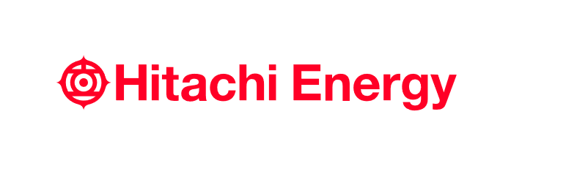
- End -

About Hitachi Energy Ltd.
Hitachi Energy is a global technology leader that is advancing a sustainable energy future for all. We serve customers in the utility, industry and infrastructure sectors with innovative solutions and services across the value chain. Together with customers and partners, we pioneer technologies and enable the digital transformation required to accelerate the energy transition towards a carbon-neutral future. We are advancing the world's energy system to become more sustainable, flexible and secure whilst balancing social, environmental and economic value. Hitachi Energy has a proven track record and unparalleled installed base in more than 140 countries. We integrate more than 150 GW of HVDC links into the power system, helping our customers enable more wind and solar. Headquartered in Switzerland, we employ more than 40,000 people in 90 countries and generate business volumes of over $10 billion USD.
https://www.hitachienergy.com
https://www.linkedin.com/company/hitachienergy
https://twitter.com/HitachiEnergy

About Hitachi, Ltd.
Hitachi drives Social Innovation Business, creating a sustainable society through the use of data and technology. We solve customers' and society's challenges with Lumada solutions leveraging IT, OT (Operational Technology) and products. Hitachi operates under the business structure of "Digital Systems & Services" - supporting our customers' digital transformation; "Green Energy & Mobility" - contributing to a decarbonized society through energy and railway systems, and "Connective Industries" - connecting products through digital technology to provide solutions in various industries. Driven by Digital, Green, and Innovation, we aim for growth through co-creation with our customers. The company's consolidated revenues for fiscal year 2022 (ended March 31, 2023) totaled 10,881.1 billion yen, with 696 consolidated subsidiaries and approximately 320,000 employees worldwide. For more information on Hitachi, please visit the company's website at https://www.hitachi.com.

Contacts:
Media Contact:
Lerato Nkosi
Country Communications Manager, South and Southern Africa
Hitachi Energy Ltd.
+27 73 644 5464
lerato.nkosi@hitachienergy.com
# # #

