FOR IMMEDIATE RELEASE

Hitachi Energy invests over 30 million euros to expand transformer operations in Germany

- The expansion and modernization of the power transformer manufacturing facility in Bad Honnef will generate up to 100 new jobs in the region.
- Set for completion in 2026, the investment expands the company's global footprint and capacity at speed, addressing the accelerating demand for transformers to meet Europe’s energy transition.

Hitachi Energy today announced an investment of more than 30 million euros (approx. $32 million) in the expansion and modernization of its power transformer manufacturing facility in Bad Honnef, Germany. Expected to be completed in 2026, the project will generate up to 100 new jobs in the region and address the rising demand for transformers to support Europe's clean energy transition.

Operational since 1906, the facility in Bad Honnef is one of Hitachi Energy’s key manufacturing locations in Europe. The factory produces large power transformers, forming critical components of the electrical grid used to step up or down the voltage level for efficient transmission and distribution.

“Electricity will be the backbone of our entire energy system. In the global power system of 2050, we need around four times the power generation capacity and transfer of up to three times as much electrical energy compared to 2020”, said Bruno Melles, Business Unit Transformers Managing Director at Hitachi Energy. “The Bad Honnef facility is one example of our commitment to expand our global footprint and capacity at speed to meet accelerating demand driven by the energy transition.”

The investment signifies an expansion of the facility to over 15,000 square meters. Combined with process enhancements, the upgraded facility is geared towards optimizing operational performance and boosting the overall manufacturing capacity to address the growing demand. Over the years, the factory in Bad Honnef has delivered transformers to many of the leading transmission system operators, utilities and industries in Europe, such as those included in the strategic partnership with TenneT.

The expansion of this factory reflects a wider scaling up of Hitachi Energy’s capacity in Europe. Last year, the company expanded production in Sweden with an additional 2,000 new jobs over the next two years, in addition to the acquisition of power electronics companies eks Energy and COET.

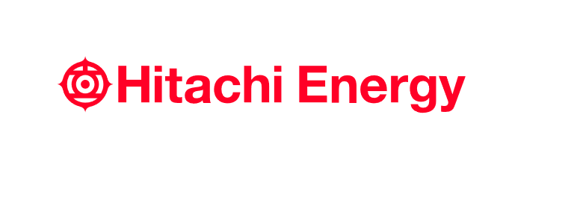
- End -

About Hitachi Energy Ltd.
Hitachi Energy is a global technology leader that is advancing a sustainable energy future for all. We serve customers in the utility, industry and infrastructure sectors with innovative solutions and services across the value chain. Together with customers and partners, we pioneer technologies and enable the digital transformation required to accelerate the energy transition towards a carbon-neutral future. We are advancing the world's energy system to become more sustainable, flexible and secure whilst balancing social, environmental and economic value. Hitachi Energy has a proven track record and unparalleled installed base in more than 140 countries. We integrate more than 150 GW of HVDC links into the power system, helping our customers enable more wind and solar. Headquartered in Switzerland, we employ more than 40,000 people in 90 countries and generate business volumes of over $10 billion USD.
https://www.hitachienergy.com
https://www.linkedin.com/company/hitachienergy
https://twitter.com/HitachiEnergy

About Hitachi, Ltd.
Hitachi drives Social Innovation Business, creating a sustainable society through the use of data and technology. We solve customers' and society's challenges with Lumada solutions leveraging IT, OT (Operational Technology) and products. Hitachi operates under the business structure of "Digital Systems & Services" - supporting our customers' digital transformation; "Green Energy & Mobility" - contributing to a decarbonized society through energy and railway systems, and "Connective Industries" - connecting products through digital technology to provide solutions in various industries. Driven by Digital, Green, and Innovation, we aim for growth through co-creation with our customers. The company's consolidated revenues for fiscal year 2022 (ended March 31, 2023) totaled 10,881.1 billion yen, with 696 consolidated subsidiaries and approximately 320,000 employees worldwide. For more information on Hitachi, please visit the company's website at https://www.hitachi.com.

Contacts:
Media Contact:
Lerato Nkosi
Country Communications Manager, South and Southern Africa
Hitachi Energy Ltd.
+27 73 644 5464
lerato.nkosi@hitachienergy.com
# # #

