FOR RELEASE ON JAN 27, 2022

Hitachi Energy achieves 100% fossil free electricity in own operations

The global technology and market leader in power grids has achieved the first-step target in its Sustainability 2030 plan and steps up the pace towards carbon-neutral
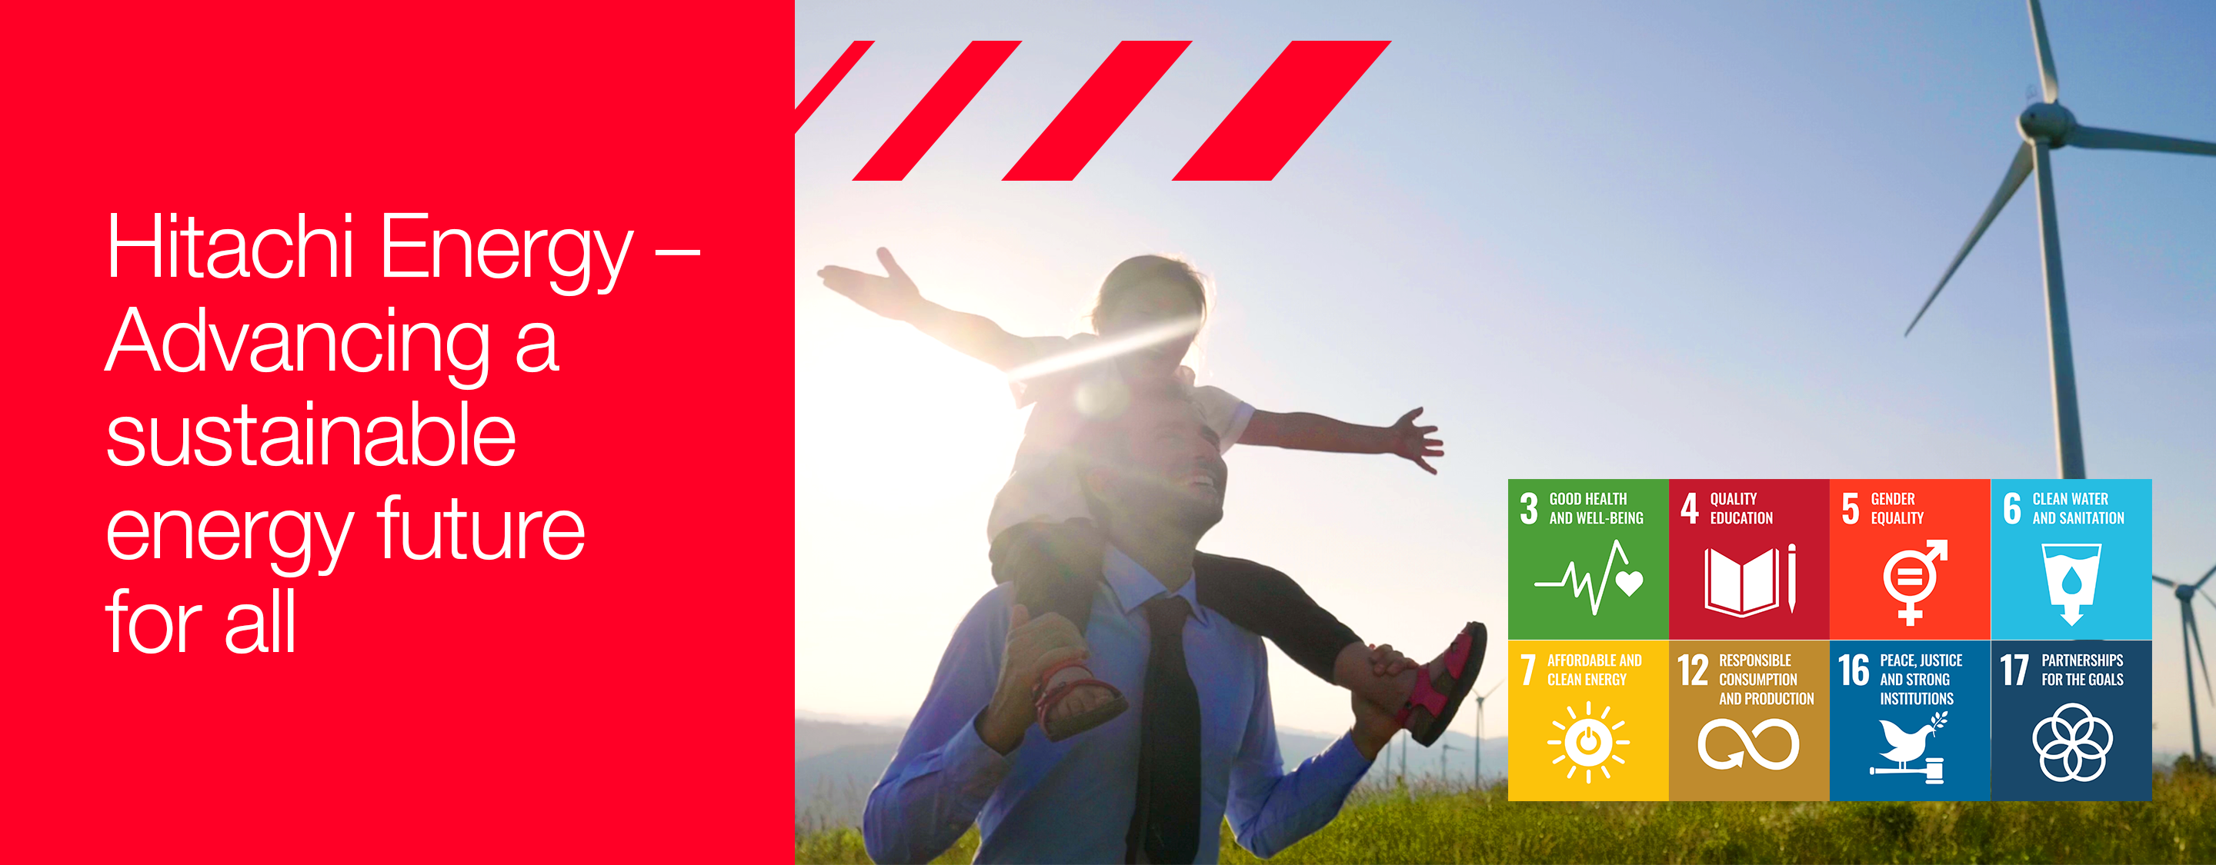

Zurich, January 27, 2022 – Hitachi Energy today announced that it has achieved the first-step target set out in its Sustainability 2030 plan – the use of 100% fossil-free electricity in its own operations¹. The company is driving towards being carbon-neutral in its own operations by 2030², in line with its Purpose, ‘Advancing a sustainable energy future for all’.

“By achieving 100% fossil-free electricity in our own operations, we have reduced our CO₂ equivalent emissions by over 50% compared to 2019,” says Claudio Facchin, CEO of Hitachi Energy. He continued, “The Net Zero challenge is global and it’s about acting now, innovating and collaborating across countries, industries and societies. Together with customers, partners, and all stakeholders, we are advancing the world’s energy system to be more sustainable, flexible and secure.”

The targeted 50% reduction achieved ahead of plan will amount to approximately 175 kilo tonnes of CO2e per year, equivalent to removing over 35,000 passenger cars off the road.

To achieve 100% fossil-free electricity in its own operations – and in support of the Hitachi Group’s carbon-neutrality goal³ – the company has pursued a number of pathways including supporting projects to generate its own fossil-free electricity, such as installing solar roof panels combined with e-meshTM digital solutions for distributed energy resources maximizing energy efficiency and minimizing CO₂ emissions. In its Zhongshan factory in China, the company is generating nearly 20% of its total energy consumption from solar panels. In its first year of operation, the power generated at the factory is expected to reach 1,510 megawatt hours (MWh), contributing to the reduction in annual carbon emissions by more than 1,000 tonnes.

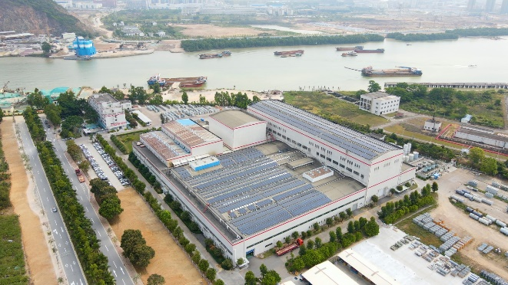
Photovoltaic installation, Zhongshan, China

To achieve 100% fossil-free electricity, Hitachi Energy has also switched to green tariffs, bought Energy Attribute Certificates (EACs), and signed Power Purchase Agreements (PPAs) across its operations and facilities in 90 countries.

Looking ahead, Hitachi Energy is continuing to invest in its journey towards carbon-neutrality by further increasing energy efficiency, as well as electrifying its own operations. In Ludvika, Sweden, the company is now using 100% renewable electricity generated from hydropower and from solar panels to support its operations. Ludvika, which is one of Hitachi Energy’s largest production facilities, has gone beyond tackling its electricity supply and is now close to removing the use of all fossil fuels from the whole of its operations.

The company has a track record of implementing its own technologies in its operations to enable the integration of renewable energy. For example, in 2015 its South Africa operations installed a 750 kW rooftop photovoltaic plant and a 1 MVA/380 kWh battery-based PowerStoreTM for enhancing the use of renewables and providing a continuous supply of power.

Through its Sustainability 2030 plan and targets, the company reinforces its commitment to accelerating actions driving business in a sustainable way. Based around four pillars – Planet, People, Peace, and Partnerships – the strategy draws from the UN’s Sustainable Development Goals (SDGs), with specific focus on the following eight: 3 (Good health and well-being), 4 (Quality education), 5 (Gender equality), 6 (Clean water and sanitation), 7 (Affordable and clean energy), 12 (Responsible consumption and production), 16 (Peace, justice and strong institutions); and 17 (Partnerships for the Goals). In line with these SDGs, each pillar has corresponding targets that drive the business to contribute social, environmental, and economic value.

Notes
1. The contract for its South Korea operations (equivalent to 0.4% total electricity usage) is expected to be signed in February 2022 retrospectively through green tariffs.

2. Discover more about Hitachi Energy’s approach to Sustainability 2030 here

3. Hitachi Sustainability Report 2021

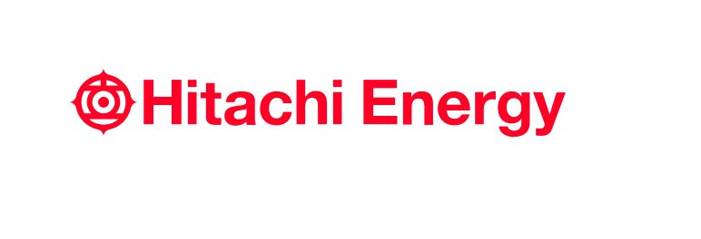
– End –

About Hitachi Energy Ltd.
Hitachi Energy is a global technology leader that is advancing a sustainable energy future for all. We serve customers in the utility, industry and infrastructure sectors with innovative solutions and services across the value chain. Together with customers and partners, we pioneer technologies and enable the digital transformation required to accelerate the energy transition towards a carbon-neutral future. We are advancing the world’s energy system to become more sustainable, flexible and secure whilst balancing social, environmental and economic value. Hitachi Energy has a proven track record and unparalleled installed base in more than 140 countries. Headquartered in Switzerland, we employ around 38,000 people in 90 countries and generate business volumes of approximately $10 billion USD.
https://www.hitachienergy.com
https://www.linkedin.com/company/hitachienergy
https://twitter.com/HitachiEnergy

About Hitachi, Ltd.
Hitachi, Ltd. (TSE: 6501), headquartered in Tokyo, Japan, contributes to a sustainable society with a higher quality of life by driving innovation through data and technology as the Social Innovation Business. Hitachi is focused on strengthening its contribution to the Environment, the Resilience of business and social infrastructure as well as comprehensive programs to enhance Security & Safety. Hitachi resolves the issues faced by customers and society across six domains: IT, Energy, Mobility, Industry, Smart Life and Automotive Systems through its proprietary Lumada solutions. The company’s consolidated revenues for fiscal year 2020 (ended March 31, 2021) totaled 8,729.1 billion yen ($78.6 billion), with 871 consolidated subsidiaries and approximately 350,000 employees worldwide. For more information on Hitachi, please visit the company's website at https://www.hitachi.com.

Media Contact:
Rebecca Bleasdale
Head of External Communications, Content & Media Relations
+41 78 643 26 13
rebecca.bleasdale@hitachienergy.com

