PRESS RELEASE
Mineral product eliminates mycotoxins
12 October 2021: Recent news articles reporting elevated mycotoxin levels found in some fruit juices has again placed the spotlight on the occurrence of this natural toxic substance.
Mycotoxins are toxic compounds produced naturally by certain types of moulds (fungi). Moulds that can produce mycotoxins can grow on numerous foodstuffs such as beverages, cereals, dried fruits, nuts and spices as well as pet foods.
Pratley produces a registered mineral additive branded as Clinomix®. This is a type of zeolite called clinoptilolite, a completely natural mineral mined and processed locally by the company. Clinomix® is most notably used as an animal food additive as it is a highly effective mycotoxin binder effective in eliminating 99.9% of deadly mycotoxins in feed. As a result, many producers are now adding the product to their formulations.
Dangerous mycotoxins which may be present in certain foods are effectively bound when using Clinomix®. Bound mycotoxins can then safely pass through the gastrointestinal tract without the danger of these harmful toxins being absorbed.
Efficacy tests carried out by the SANAS-approved SGS Agri Food Laboratory concluded that Clinomix® is extremely effective at binding mycotoxins. In a sample in which the initial aflatoxin count was 4196 µg/kg, following treatment with Clinomix®, the total aflatoxin levels dropped to below 4 µg/kg. The table below summarises the mycotoxin binding effect of Clinomix®:
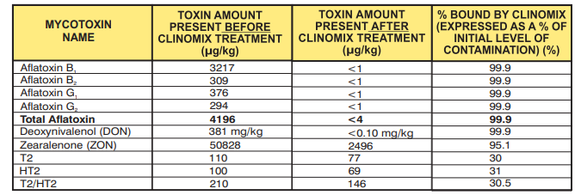
Clinomix® is part of a range of mineral products produce and marketed by Pratley specifically for mycotoxin removal. A similar product called Clinoxin® is a broad-spectrum mycotoxin binder specifically for the poultry industry. It also reduces ammonia levels and faecal moisture in poultry houses.
Clinoxin® and Clinomix® are registered stock remedies with the South African Department of Agriculture. Both products are available from Pratley in 25 kg bags and 50 kg bulk bags.
Connect with Pratley on Social Media to receive the company’s latest news
Facebook: https://www.facebook.com/PratleySA/
Twitter: https://twitter.com/PratleySA
Ends
Notes to the editor
To download hi-res images for this release, please visit http://media.ngage.co.za and click on the Pratley Group link to view the company’s press office.
About Pratley
Established in 1948 by George ‘Monty’ Pratley, the various companies in the Pratley stable rest on a foundation of research and innovation in both the manufacturing and mining sectors. The various Pratley companies, drawing from 73 years of experience, have filed over 350 patents worldwide, and are ISO 9001 certified. Operating divisions are Pratley Adhesives, Pratley Electrical, Pratley Minerals, Pratley Craft & Decoupage, and Select Hairdressing Supplies.
Pratley Contact
Sales
Phone: (011) 955 2190
Fax: (011) 955 3918
Email: sales@pratley.co.za
Web: www.pratleyminerals.com
Media Contact
Emma Anderson
Account Executive
NGAGE Public Relations
Phone: (011) 867-7763
Fax: 086 512 3352
Cell: 078 028 3553
Email: emma@ngage.co.za
Web: www.ngage.co.za
Browse the NGAGE Media Zone for more client press releases and photographs at http://media.ngage.co.za

