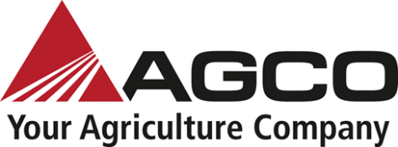
NEWS RELEASE
www.AGCOcorp.com

For immediate release

AGCO Africa Contact
Robert Keir
Brand Marketing Communications Specialist, Africa
Email: Robert.Keir@agcocorp.com
+27 82 349 7441
Latest German-engineered Fendt 900 and 1100 Vario multi-tracked tractors available in South Africa

Fendt is a global leader in building high horsepower tracked tractors, with over 30 years’ experience

Johannesburg, South Africa, 3 September 2021: The secret to healthy crops and high yields lies in the soil. Therefore, managing the soil efficiently and with care ensures long-term economic success for farmers. In addition to efficiency and comfort, soil protection is Fendt’s top priority when developing tractors. A global leader in building high horsepower tracked tractors, with over 30 years’ experience, the Fendt 900 Vario and Fendt 1100 Vario are the latest additions to the track tractors range available locally from your nearest Fendt South African Dealer, reports Frans Cronje, Regional Sales Manager for Fendt, AGCO Africa.

Unlike other tracked tractors, the Fendt 900 Vario MT (Multi-Tracked) is not a variation of a wheeled tractor, but instead has been developed as a pure tracked tractor. In terms of the track system, the wheelbase has been extended to 2 565 mm, which is 13 cm longer than previous versions. The total ground contact area is 3.25 m² on 25" wide tracks, 3.90 m² with 30" and a hefty 4.42 m² on 34" tracks. This equates to more traction, less soil pressure and an optimal weight distribution across the entire contact area, even in the case of a heavy load, all combined with optimised driving comfort and reduced ground compaction.

The Fendt 1100 Vario MT is the first tracked tractor in this class to feature a stepless drive. The Vario transmission has been revised and adapted to the special requirements of a tracked tractor. The introduction of the stepless Vario transmission greatly increases overall efficiency. The newly-developed SmartRide suspension combined with two options of cab suspension provides unprecedented driving comfort for a tracked tractor.

With the innovative SmartRide suspension system, the hard bar is mounted on the frame using coil springs, shock absorbers and silent rubber blocks, offering a considerable overall suspension stroke of 217 mm. The central carrier can oscillate by 11° for best ground-hugging. A coupling rod (Panhard bar) prevents any movement to the side and stabilises the tracks lengthways.

The three rollers of the undercarriage are attached to the chassis frame in a unique bogie-in-bogie system allowing for long travel distances and adaptive ground tracking. The weight is distributed evenly across the track to the ground maximizing traction. A wide range of tracks is available for the Fendt 900 Vario MT, with two designed especially for agricultural use and two enhanced versions for special applications.

The all-new Fendt 900 Vario MT
The Fendt 900 Vario MT has a powerful and highly efficient seven-cylinder AGCO Power engine with a 9,8 litre cubic capacity, generating up to 317 kW/431 hp at a rated speed of just 1 700 rpm. Two in-line turbochargers with fixed geometry provide constant power generation. The maximum torque of 1.921 Nm is reached at just 1 450 rpm thanks to the Fendt iD low-speed concept. The engine speed range is between 1 000 and 1 700 rpm, while the engine idle speed is just 800 rpm.

The Fendt 1100 Vario MT is the most powerful
The Fendt 1100 Vario MT range has four models to choose from, ranging from 511 hp to 618 hp. The MAN six-cylinder in-line engine offers a cubic capacity of 15.2 litres on the Fendt 1151 Vario MT, 1156 Vario MT and 1162 Vario MT models. The high-end Fendt 1167 Vario MT model boasts 16.2 litres, providing an unbeatable 673 hp to the auxiliary power consumers under extremely high-power requirements. A Common Rail system with an injection pressure of up to 2 500 bar and a turbo-supercharger with variable turbine-geometry (VTG) deliver the power evenly and dynamically, even at low engine speeds.

Efficient cooling is ensured by the unique Fendt Fan and Concentric Air System (CAS) cooling concept. Here a forced-draft high-performance fan is positioned in front of the cooler unit where it sucks in cool dense air, accelerates it via the concentric hood and pushes it through the cooler. The CAS has its own hydrostatic drive, so it can always deliver ideal cooling power to each component according to need, independent of the engine speed. The fan is tilted upwards to prevent harvesting residue from being sucked up from the ground.

The revolutionary Fendt VarioDrive drivetrain from the standard tractor Fendt 1000 Vario has been extensively and optimally adapted for the Fendt 900 Vario MT. The result is an innovative and efficient continuously variable drive for tracked tractors that meets all practical requirements. As a result, you can drive without manually changing speed ranges. This allows the tractor to operate at optimal engine speed with, maximising performance and fuel efficiency.

The heart of the VarioDrive drivetrain are large and powerful hydrostatic devices with a capacity of 370 cm³ each. The hydro motors can swivel independently of each other to allow the VarioDrive drivetrain to achieve maximum efficiency. This is amplified when a hydro motor is decoupled at higher speeds (more than about 20 km/h) as soon as it swivels back. The Fendt 900 Vario MT achieves a transport speed of 40 km/h at a very low 1 550 rpm. The renowned Tractor Management System (TMS), along with automatic maximum load control, ensures that the Fendt 900 Vario MT delivers the most efficient results every time, without having to make any elaborate settings. Together with the Fendt iD low engine speed concept, this translates into the lowest possible fuel consumption.

Whether heavy tillage, or higher speed applications, a wide range of ballast options on the Fendt 1100 Vario MT tracked tractor caters for any kind of work. The tracked tractor offers ballasting options on the rear drive wheels, the front guide wheel, with added weights on the sides of the tracked drive and at the front due to a variety of front weights. With light ballasting and higher speeds on the field, Fendt tracked tractors can pull a precision planter, while heavy ballasting and low speeds are ideal for heavy-duty soil cultivation.

A special feature of the Fendt 1100 Vario MT is the exclusive pivoting rear power lift. The pivoting rear power lift with three-point suspension has a movement radius of 12° in both directions. This means the pivot point of the attachment moves to the tractor’s natural pivot point and the attachment runs with much more directional stability combined with a tracking system. If there is an obstacle on the field dragging the attachment on the side, the attachment can swerve around it without the tracked tractor leaving the track.

The Fendt 1100 Vario MT also comes into its own when following irregular field boundaries with the pivoting rear power lift. The contour is followed with full care and precision, even with large attachments in tow. The pivoting rear power lift mean less effort is required for steering, with far less wear. Overall fuel consumption is reduced and working speed is improved, further increasing the efficiency of the new Vario MT series.

In order for the driver to obtain the best performance from the machine, it is essential that the workstation is ergonomic, clear and easy-to-use. Therefore, the Fendt 1100 Vario MT is fitted with the trusted cab from the Fendt 900 Vario MT. This spacious Fendt cab offers plenty of room and provides excellent visibility and ease-of-use in classic Fendt fashion. Machine parameters are easy to control and monitor on the Varioterminal 10.4" with large touch screen. Machine operation is quick and ergonomic, with the familiar Fendt multifunction armrest and built-in Fendt multifunction joystick.

In support of the farming community, Fendt has a nationwide dealer network covering the whole of South Africa, offering service, sales and support. For further information, and to get in touch with your closest dealer, visit www.fendt.com/za.

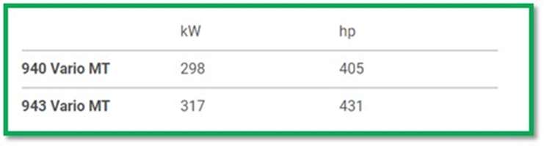

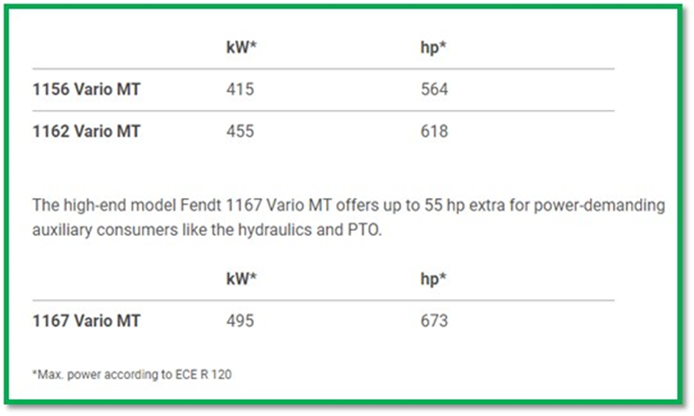

Ends

Notes to the Editor
To download hi-res images for this release, please visit http://media.ngage.co.za and click the Fendt link to view the company’s press office.

About Fendt
Fendt is the leading hi-tech brand within the AGCO Corporation for customers who demand nothing but the best quality from machines and services. Fendt tractors and harvesting machines work around the globe, both on professional farms and in non-agricultural applications. Customers benefit from innovative technology to improve performance, efficiency and profitability. Using resource-friendly solutions from Fendt helps farmers and contractors worldwide to work in a sustainable way.
At its German sites in Marktoberdorf, Asbach-Bäumenheim, Hohenmölsen, Feucht, Waldstetten and Wolfenbüttel, AGCO employs around 6 000 people in the areas of Research & Development and Sales & Marketing as well as Production, Service and Administration.
www.fendt.com/za, www.fendt.tv, www.facebook.com/fendtSouthAfrica, www.youtube.com/FendtTV, www.instagram.com/fendt.global

About AGCO
AGCO (NYSE:AGCO) is a global leader in the design, manufacture and distribution of agricultural machinery and precision ag technology. AGCO delivers customer value through its differentiated brand portfolio including core brands like Challenger®, Fendt®, GSI®, Massey Ferguson® and Valtra®. Powered by Fuse® smart farming solutions, AGCO’s full line of equipment and services helps farmers sustainably feed our world. Founded in 1990 and headquartered in Duluth, Georgia, USA, AGCO had net sales of $9.1 billion in 2020. For more information, visit www.AGCOcorp.com
For company news, information and events, please follow us on Twitter: @AGCOCorp. For financial news on Twitter, please follow the hashtag #AGCOIR.

Media Contact
Nomvelo Buthelezi
PR Accounts Manager
NGAGE Public Relations
Phone: (011) 867-7763
Fax: 086 512 3352
Cell: 083 4088 911
Email: nomvelo@ngage.co.za
Web: www.ngage.co.za
Browse the NGAGE Media Zone for more client press releases and photographs at http://media.ngage.co.za

