Federal-Mogul Motorparts to Introduce New Champion® Range
at Equip Auto 2017
MOOG® NASCAR® Whelen Euro Series sponsorship and innovative
new products to be featured at the show

03 October 2017… Federal-Mogul Motorparts, a division of Federal-Mogul LLC, will exhibit at Equip Auto in Paris from the 17th to 21st of October. The show will be held in Porte de Versailles, and the Federal-Mogul Motorparts booth will be located in Hall 1, at Stand E 040.

During the show, the company will be launching a range extension from its Champion® brand for a complete service offering of high quality components. Other novelties and activities will also be revealed, aimed at further developing relationships with distributors and technicians across Europe.

This year the booth will also feature a car from the NASCAR® Whelen Euro Series, which is sponsored by MOOG®, Federal-Mogul Motorparts’ steering, suspension, chassis and wheel-end bearing brand. MOOG is supplying all competition cars with steering and suspension components, complementing the long running partnership between MOOG and NASCAR in the United States, which has existed for 51 years.

“Federal-Mogul Motorparts will be announcing exciting news at Equip Auto this year,” explained Jérôme Gendre, Managing Director, Western Europe, Federal-Mogul Motorparts. “We are constantly looking at how to improve our products and customer experience, and we are looking forward to showing off both in October.”

The company will also present a wide portfolio of products across their other brands, including Payen®, Jurid® and Ferodo®.
“Federal-Mogul Motorparts is a one-stop-shop, as we offer a wide variety of high quality components that consumers and garages can trust,” added Gendre. “Equip Auto is a very important event on the aftermarket calendar and is vital for our business in Western Europe.”

About Federal-Mogul
Federal-Mogul LLC is a leading global supplier of products and services to the world’s manufacturers and servicers of vehicles and equipment in the automotive, light, medium and heavy-duty commercial, marine, rail, aerospace, power generation and industrial markets. The company’s products and services enable improved fuel economy, reduced emissions and enhanced vehicle safety.

Federal-Mogul operates two independent business divisions, each with a chief executive officer reporting to Federal-Mogul's Board of Directors.

Federal-Mogul Motorparts sells and distributes a broad portfolio of products through more than 20 of the world’s most recognized brands in the global vehicle aftermarket, while also serving original equipment vehicle manufacturers with products including braking, wipers and a range of chassis components. The company’s aftermarket brands include ANCO® wipers; Beck/Arnley® premium OE quality parts and fluids; BERU®* ignition systems; Champion® lighting, spark plugs, wipers and filters; Interfil® filters; AE®, Fel-Pro®, FP Diesel®, Goetze®, Glyco®, National®, Nüral®, Payen®, Sealed Power® and Speed-Pro® engine products; MOOG® chassis components; and Abex®, Ferodo®, Jurid® and Wagner® brake products and lighting.

Federal-Mogul Powertrain designs and manufactures original equipment powertrain components and systems protection products for automotive, heavy-duty, industrial and transport applications.

Federal-Mogul was founded in Detroit in 1899 and maintains its worldwide headquarters in Southfield, Michigan. The company employs nearly 53,000 in 24 countries. For more information, please visit www.FMmotorparts.eu

*BERU is a registered trademark of BorgWarner Ludwigsburg GmbH

CONTACT:
Name, Phone, Email

IMAGES:
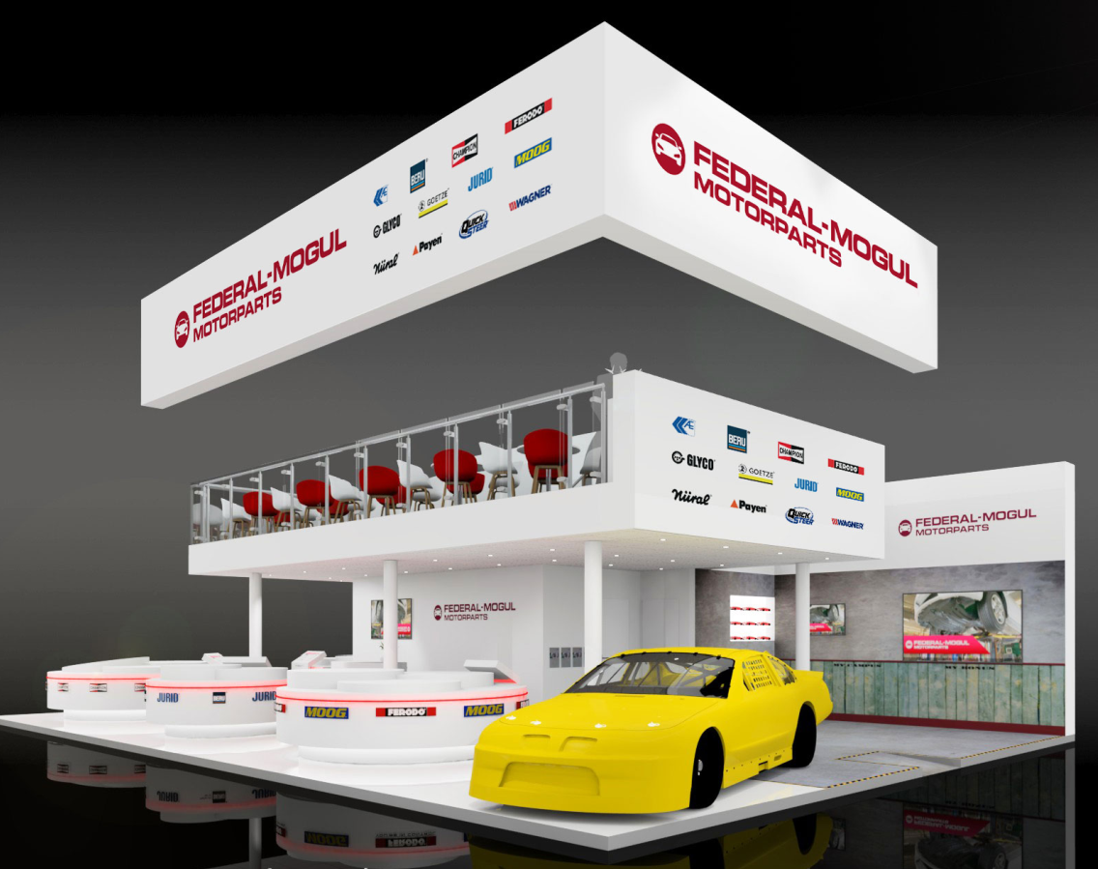 | Federal-Mogul Motorparts (stand E 040 in Hall 1) will present its new programs and product launches at this year’s Equip Auto in Paris (17th-21st October)
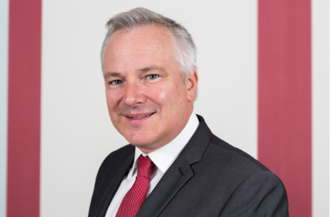 | “Equip Auto is a very important event on the aftermarket calendar and is vital for our business in Western Europe,” said Jérôme Gendre, Managing Director, Western Europe, Federal-Mogul Motorparts.

