Where is social media headed to in 2017?
Social media is one of the fastest changing industries out there. Sometimes a cutting-edge technology changes the social game, or an old idea (e.g. virtual reality) gains viral popularly. Either way, the results always have a huge impact and 2017 will be no different. Here are three social media trends that will dominate 2017.
The standardization of platforms
2016 has been a period of consolidation for many of the biggest social media platforms out there. It seems that most products launch in a niche, with a unique perspective or angle, and then once they begin to hit critical mass, they start to blend into one another.
The blur between Snapchat and Instagram isn’t the only case of platform consolidation we’ve seen in 2016 either. For example:
- YouTube is testing community features allowing creators to share text and image based posts (aka, Facebook)Facebook is trying to be the go-to place for news and trending stories (aka, Twitter)Facebook is testing disappearing messages in Messenger (aka, Snapchat)
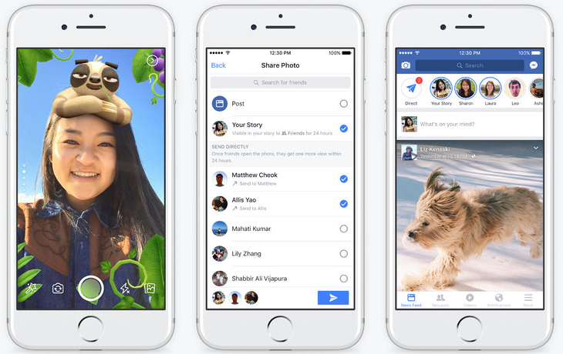
In 2017, I believe we’ll likely see more of this trend with every the major platform battling it out to become the go-to place for short, snackable and in-the-moment content. And by the end of 2017, we’ll likely see most of the major platforms enabling users to:
- Create and share video content
- Create and share live video content
- Discover news and what’s going on around them (based on location)
Chatbots
Chatbots are a kind of artificial intelligence that can have a conversation with someone. Facebook had integrated them within Facebook Messenger, and businesses are now using them to communicate with customers.
Chatbots are already helping businesses improve customer service by quickly responding to their comments and questions. You can only expect the tool to become more popular in 2017 -- especially since social media sites are doing everything they can to keep people on their platform instead of navigating away to a business website.
Chatbots already have the intelligence and ability to help people consume content, answer questions, and complete transaction. More than a third of people already prefer social media over a phone call for customer support. Millennials want self-service and like to resolve their customer service issues mainly technology as it’s fast, efficient, and brief.
Growth of Search
In Facebook’s Q2 earnings report, Mark Zuckerberg revealed that Facebook now sees 2 billion searches per day, up from 1.5 billion a year ago. Google still leads the way in search, with 3.5 billion searches per day. But with Facebook showing strong growth in this area, it may not be too long before we see Facebook pursuing the ad dollars traditionally reserved for Google.
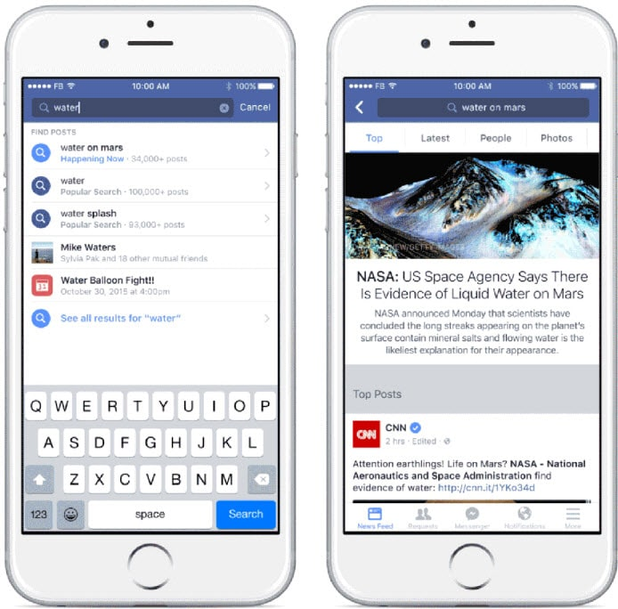
Search could also prove to become a key part of increasing your reach on Facebook and driving attention to the content you post on the platform. It’ll be interesting to see how this unfolds and it definitely feels like a topic we’ll dive into more on the Buffer Social blog over the coming months.

Sources and References:
Buffer Social - Link: www.buffer.com
Forbes New Tech - www.forbes.com

