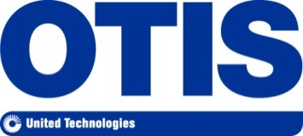

For Immediate Release Contact: Hayley Elwen
(011) 878 6029
Hayley.elwen@utc.com

Otis Acquires Service Business of ThyssenKrupp in South Africa

JOHANNESBURG, September. 8 2015 – Otis (Pty) Ltd, part of Otis Elevator, the world’s largest manufacturer and maintainer of people-moving products, including elevators, escalators and moving walkways, announced today the acquisition of the local service business of ThyssenKrupp Elevator (South Africa) (Pty.) Ltd. The transaction will give customers access to Otis expertise in service and maintenance and expand Otis’ capabilities in the region. Otis is a part of UTC Building & Industrial Systems, a unit of United Technologies Corp. (NYSE: UTX).
“This acquisition will increase our operational footprint, connecting us with new customers and increasing the number of units we maintain and repair,” said Segren Reddy, managing director, Otis Southern Africa. “We believe this acquisition will result in great benefits for our new and existing customers, including the opportunity to discuss Otis solutions for new equipment and modernisation products in building rejuvenation projects in South Africa.”
Employees currently working for ThysssenKrupp will be incorporated into Otis business units. Terms of the transaction will not be disclosed. For more information about Otis, visit www.otis.com/site/za.
About Otis
Otis is the world’s largest manufacturer and maintainer of people-moving products, including elevators, escalators and moving walkways. Founded more than 160 years ago by the inventor of the safety elevator, Otis offers products and services through its companies in more than 200 countries and territories, and maintains more than 1.8 million elevators and escalators worldwide. Otis is a part of UTC Building & Industrial Systems, a unit of United Technologies Corp., a leading provider to the aerospace and building systems industries worldwide. For more information, visit www.otis.com or follow @OtisElevatorCo on Twitter.

